WEEK 7_REACT
9. ReactJS-HOL
Create a React Application named “cricketapp” with the following components:
- ListofPlayers
- IndianPlayers
Code:
ListofPlayers.js
import React from 'react';
const ListofPlayers = () => {
const players = [
{ name: 'Mr. Jack', score: 50 },
{ name: 'Mr. Michael', score: 70 },
{ name: 'Mr. John', score: 40 },
{ name: 'Mr. Ann', score: 61 },
{ name: 'Mr. Elisabeth', score: 61 },
{ name: 'Mr. Sachin', score: 95 },
{ name: 'Mr. Dhoni', score: 100 },
{ name: 'Mr. Virat', score: 84 },
{ name: 'Mr. Jadeja', score: 64 },
{ name: 'Mr. Raina', score: 75 },
{ name: 'Mr. Rohit', score: 80 }
];
const lowScorers = players.filter(player => player.score < 70);
return (
<div>
<h2>List of Players</h2>
<ul>
{players.map((player, index) => (
<li key={index}>{player.name} {player.score}</li>
))}
</ul>
<hr />
<h2>List of Players having Scores Less than 70</h2>
<ul>
{lowScorers.map((player, index) => (
<li key={index}>{player.name} {player.score}</li>
))}
</ul>
</div>
);
};
export default ListofPlayers;

IndianPlayers.js

import React from 'react';
const IndianPlayers = () => {
const T20players = ['Mr. First Player', 'Mr. Second Player', 'Mr. Third Player'];
const RanjiPlayers = ['Mr. Fourth Player', 'Mr. Fifth Player', 'Mr. Sixth Player'];
const mergedPlayers = [...T20players, ...RanjiPlayers];
const indexedPlayers = [
{ position: 'First', name: 'Sachin1' },
{ position: 'Second', name: 'Dhoni2' },
{ position: 'Third', name: 'Virat3' },
{ position: 'Fourth', name: 'Rohit4' },
{ position: 'Fifth', name: 'Yuvaraj5' },
{ position: 'Sixth', name: 'Raina6' }
];
const oddPlayers = indexedPlayers.filter((_, i) => i % 2 === 0);
const evenPlayers = indexedPlayers.filter((_, i) => i % 2 !== 0);
return (
<div>
<h2>Odd Players</h2>
<ul>
{oddPlayers.map((p, index) => (
<li key={index}>{p.position} : {p.name}</li>
))}
</ul>
<h2>Even Players</h2>
<ul>
{evenPlayers.map((p, index) => (
<li key={index}>{p.position} : {p.name}</li>
))}
</ul>
<h2>List of Indian Players Merged:</h2>
<ul>
{mergedPlayers.map((player, index) => (
<li key={index}>{player}</li>
))}
</ul>
</div>
);
};
export default IndianPlayers;

App.js

import React from 'react';
import ListofPlayers from './components/ListofPlayers';
import IndianPlayers from './components/IndianPlayers';
function App() {
const flag = false; // Switch between true/false to toggle view
return (
<div className="App">
<h1>React App</h1>
{flag ? <ListofPlayers /> : <IndianPlayers />}
</div>
);
}
export default App;

Output:

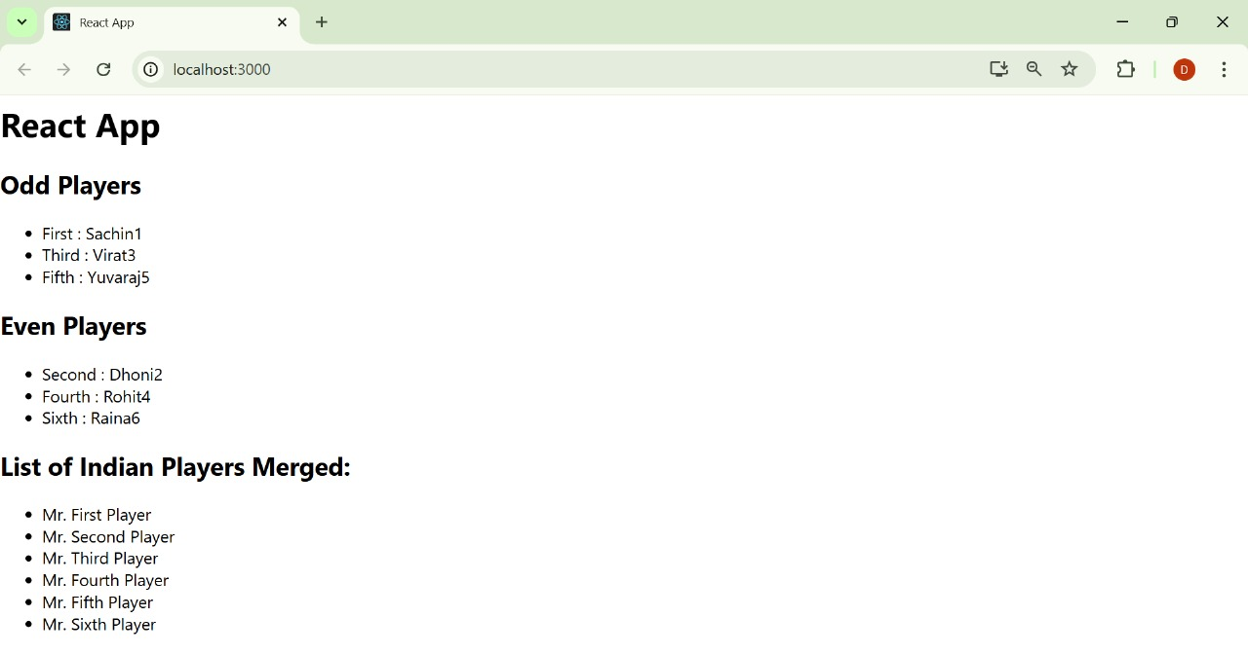

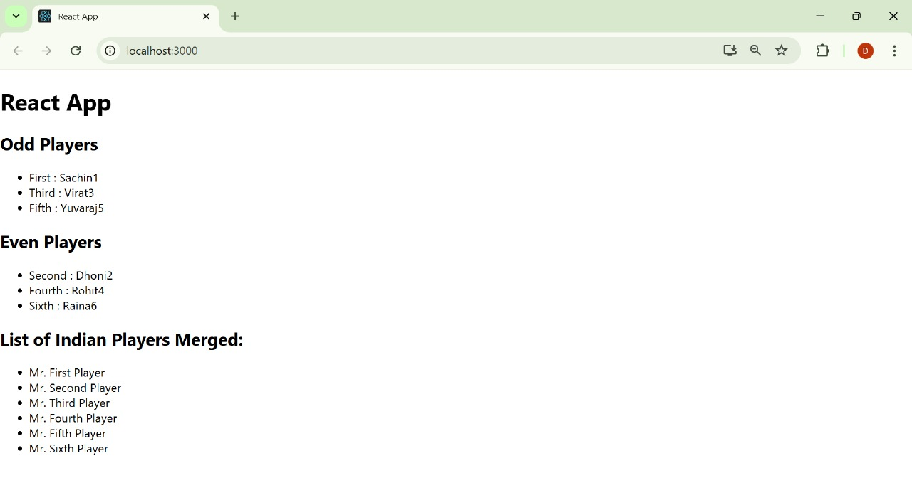

10. ReactJS-HOL
Create a React Application named “officespacerentalapp” which uses React JSX to create elements, attributes and renders DOM to display the page.
Code:
App.js
import React from 'react';
import officeImage from './assets/dbs-bank-offices-hyderabad-2-1024x683.jpg';
function App() {
const office = {
name: 'DBS',
rent: 50000,
address: 'Chennai'
};
const rentStyle = {
color: office.rent < 60000 ? 'red' : 'green',
fontWeight: 'bold'
};
return (
<div style={{ textAlign: 'center', marginTop: '40px' }}>
<h2>Office Space , at Affordable Range</h2>
<img
src={officeImage}
alt="Office"
style={{ width: '300px', height: '300px', objectFit: 'cover' }}
/>
<div style={{ fontWeight: 'bold', fontSize: '20px' }}>Name: {office.name}</div>
<div style={rentStyle}>Rent: Rs. {office.rent}</div>
<div style={{ fontWeight: 'bold' }}>Address: {office.address}</div>
</div>
);
}
export default App;

Output:

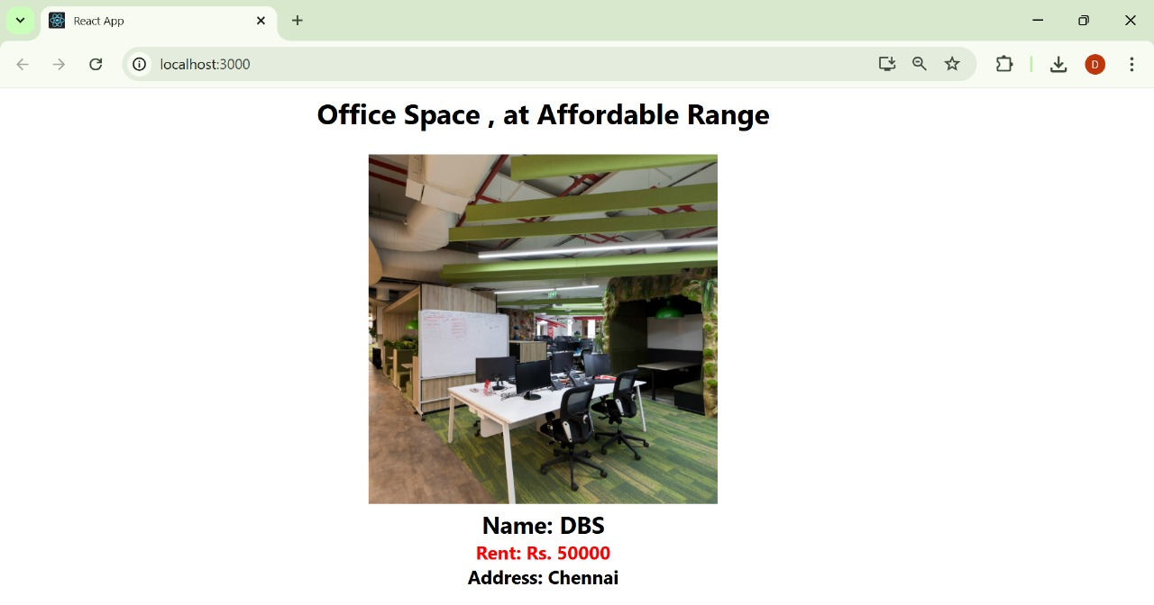

11. ReactJS-HOL
Create a React Application “eventexamplesapp” to handle various events of the form elements in HTML.

Code:
EventExamples.js
import React, { useState } from 'react';
import './EventExamples.css';
const EventExamples = () => {
const [count, setCount] = useState(1);
const increment = () => {
setCount(count + 1);
sayHello();
};
const decrement = () => {
setCount(count - 1);
};
const sayHello = () => {
console.log("Hello! This is a static message.");
};
const sayWelcome = (message) => {
alert(message);
};
const handleClick = (event) => {
alert("I was clicked");
};
return (
<div>
<p>{count}</p>
<button onClick={increment}>Increment</button>
<button onClick={decrement}>Decrement</button>
<button onClick={() => sayWelcome("Welcome!")}>Say welcome</button>
<button onClick={handleClick}>Click on me</button>
</div>
);
};
export default EventExamples;
EventExamples.css

button {
display: block;
margin: 0;
padding: 4px 8px;
font-size: 14px;
border: 1px solid #aaa;
background-color: #f0f0f0;
}
CurrencyConvertor.js

import React, { useState } from 'react';
const CurrencyConvertor = () => {
const [amount, setAmount] = useState('');
const [currency, setCurrency] = useState('Euro');
const handleSubmit = (e) => {
e.preventDefault();
let convertedAmount;
if (currency === 'Euro') {
convertedAmount = parseFloat(amount) * 80; // 1 Euro ≈ ₹80
} else {
convertedAmount = amount;
}
alert(`Converting to ${currency} Amount is ${convertedAmount}`);
};
return (
<div>
<h2 style={{ color: 'green' }}>Currency Convertor!!!</h2>
<form onSubmit={handleSubmit}>
<div>
<label>Amount: </label>
<input
type="number"
value={amount}
onChange={(e) => setAmount(e.target.value)}
/>
</div>
<div>
<label>Currency: </label>
<select value={currency} onChange={(e) => setCurrency(e.target.value)}>
<option value="Euro">Euro</option>
</select>
</div>
<button type="submit">Submit</button>
</form>
</div>
);
};
export default CurrencyConvertor;
App.js

import React from 'react';
import EventExamples from './EventExamples';
import CurrencyConvertor from './CurrencyConvertor';
function App() {
return (
<div className="App">
<EventExamples />
<CurrencyConvertor />
</div>
);
}
export default App;
index.js

import React from 'react';
import ReactDOM from 'react-dom/client';
import App from './App';
const root = ReactDOM.createRoot(document.getElementById('root'));
root.render(
<React.StrictMode>
<App />
</React.StrictMode>
);
Output:

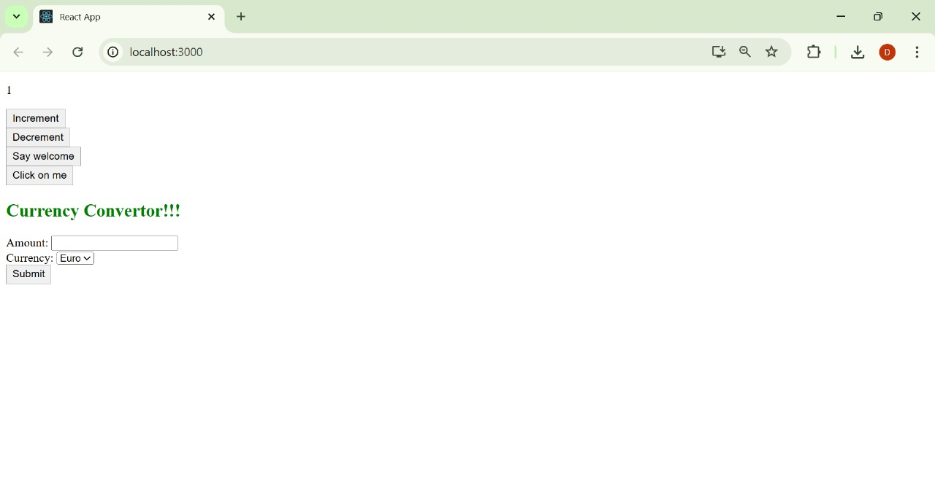
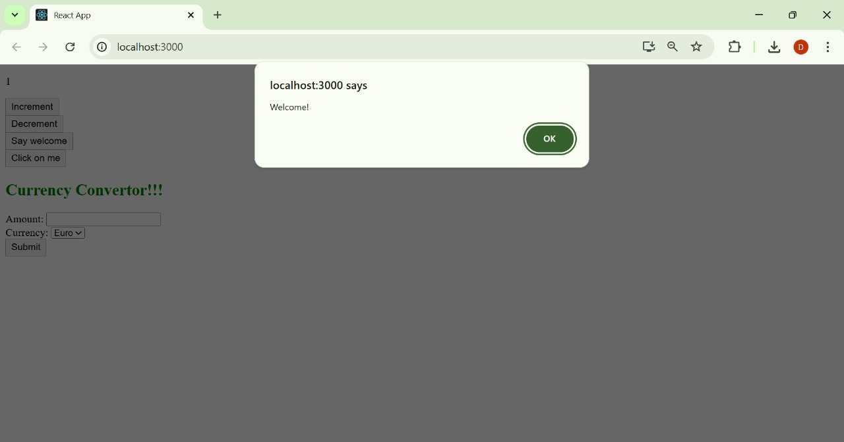

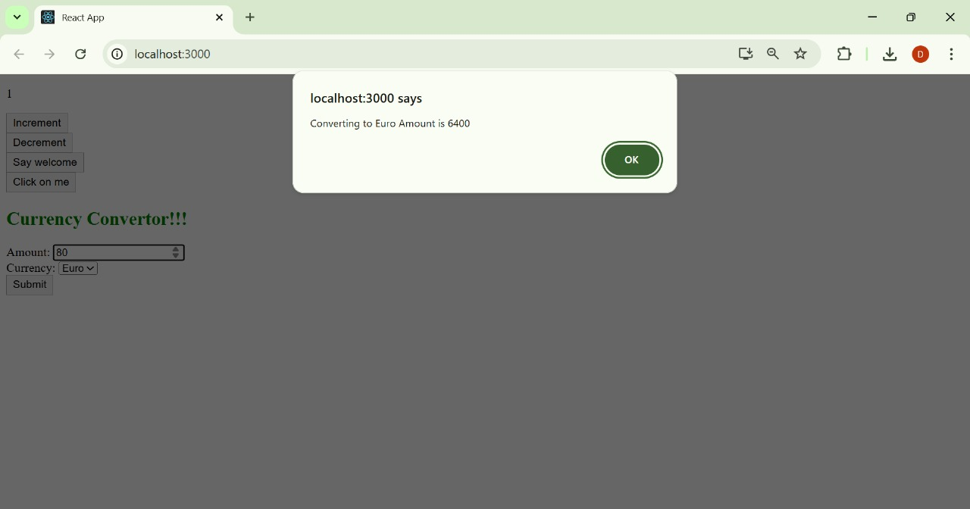

12. ReactJS-HOL
Create a React Application named “ticketbookingapp” where the guest user can browse the page where the flight details are displayed whereas the logged in user only can book tickets.
The Login and Logout buttons should accordingly display different pages. Once the user is logged in the User page should be displayed. When the user clicks on Logout, the Guest page should be displayed.

Code:
App.js
import React, { useState } from 'react';
function App() {
const [isLoggedIn, setIsLoggedIn] = useState(false);
const handleLogin = () => setIsLoggedIn(true);
const handleLogout = () => setIsLoggedIn(false);
let message;
let button;
if (isLoggedIn) {
message = <h1>Welcome back</h1>;
button = <button onClick={handleLogout}>Logout</button>;
} else {
message = <h1>Please sign up.</h1>;
button = <button onClick={handleLogin}>Login</button>;
}
return (
<div style={{ textAlign: 'center', marginTop: '100px' }}>
{message}
<br /><br />
{button}
</div>
);
}
export default App;

Output:

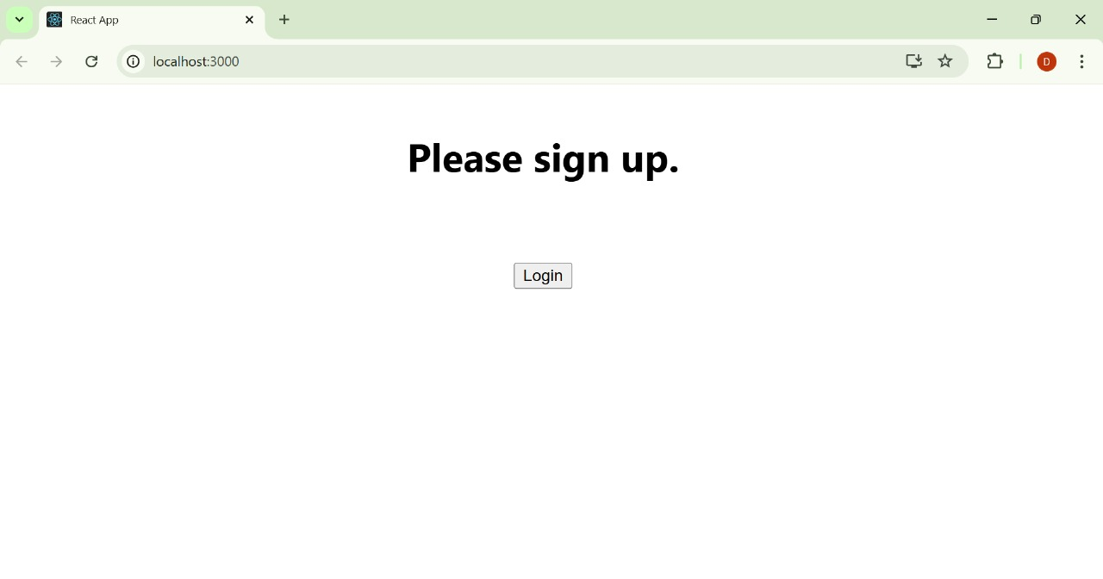
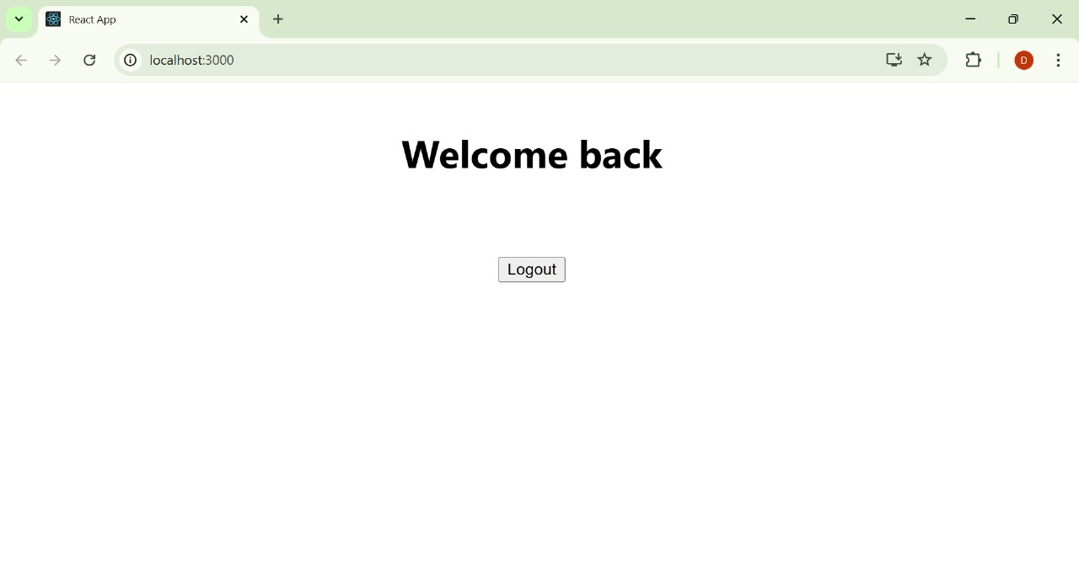

13. ReactJS-HOL
Create a React App named “bloggerapp” in with 3 components.
- Book Details
- Blog Details
- Course Details
Implement this with as many ways possible of Conditional Rendering.

Code:

CourseDetails.js
import React from 'react';
function CourseDetails() {
const courses = [
{ name: 'Angular', date: '4/5/2021' },
{ name: 'React', date: '6/3/20201' },
];
return (
<div className="section">
<h2>Course Details</h2>
{courses.map((course, index) => (
<div key={index}>
<h3>{course.name}</h3>
<p>{course.date}</p>
</div>
))}
</div>
);
}
export default CourseDetails;
BookDetails.js
import React from 'react';
function BookDetails() {
const books = [
{ title: 'Master React', price: 670 },
{ title: 'Deep Dive into Angular 11', price: 800 },
{ title: 'Mongo Essentials', price: 450 },
];
return (
<div className="section">
<h2>Book Details</h2>
{books.map((book, index) => (
<div key={index}>
<h3>{book.title}</h3>
<p>{book.price}</p>
</div>
))}
</div>
);
}
export default BookDetails;
BlogDetails.js
import React from 'react';
function BlogDetails() {
const blogs = [
{
title: 'React Learning',
author: 'Stephen Biz',
description: 'Welcome to learning React!',
},
{
title: 'Installation',
author: 'Schewzdenier',
description: 'You can install React from npm.',
},
];
return (
<div className="section">
<h2>Blog Details</h2>
{blogs.map((blog, index) => (
<div key={index}>
<h3>{blog.title}</h3>
<p><strong>{blog.author}</strong></p>
<p>{blog.description}</p>
</div>
))}
</div>
);
}
export default BlogDetails;
App.js
import React from 'react';
import CourseDetails from './CourseDetails';
import BookDetails from './BookDetails';
import BlogDetails from './BlogDetails';
import './App.css';
function App() {
return (
<div className="app">
<CourseDetails />
<BookDetails />
<BlogDetails />
</div>
);
}
export default App;
App.css
.app {
display: flex;
justify-content: space-around;
padding: 40px;
font-family: Arial, sans-serif;
}
.section {
width: 30%;
padding: 0 20px;
border-left: 5px solid green;
}
.section:first-child {
border-left: none;
}
h2 {
font-size: 24px;
margin-bottom: 15px;
}
h3 {
font-size: 20px;
margin: 10px 0 5px;
}
p {
margin: 2px 0;
}

Output:

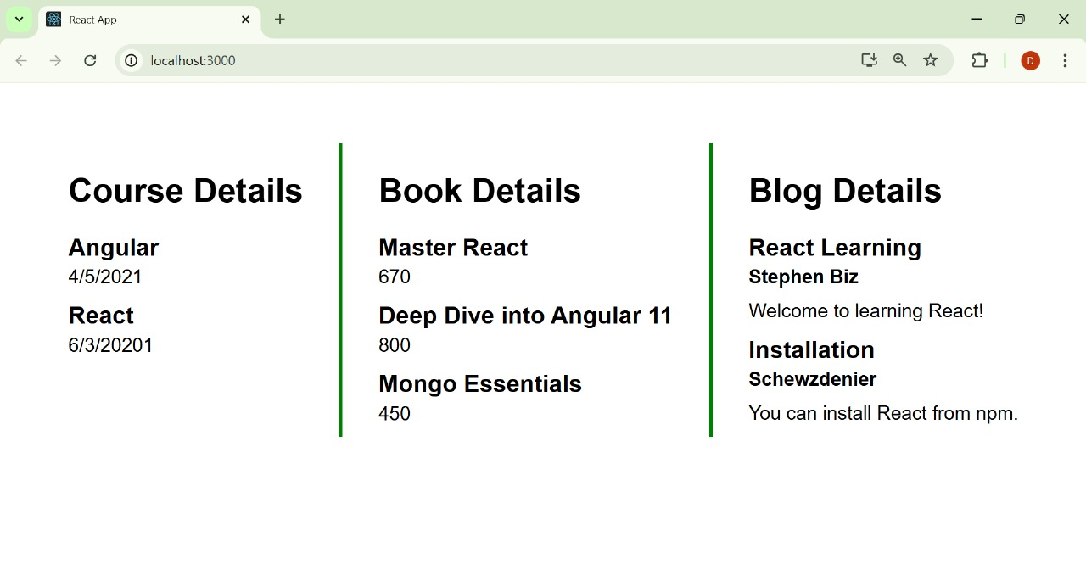
14. ReactJS-HOL
Developers of Apps Centric Solutions have created an employee management application which supports light and dark themes for the buttons. The current solution uses the react state and props to provide the theme name to be used from App component to Employee List component and from there to Employee Card component. Quality assurance team analyzed the solutions and found the technique being used to be a substandard one. React architect suggested to use the react context API to share the theme name with nested child components instead of passing them down using props from the parent component.
Code:
ThemeContext.js

import { createContext } from "react";
const ThemeContext = createContext("light");
export default ThemeContext;
App.js

import React, { useState } from "react";
import EmployeesList from "./EmployeesList";
import ThemeContext from "./ThemeContext";
function App() {
const [theme, setTheme] = useState("light");
return (
<ThemeContext.Provider value={theme}>
<div className="App">
<h1>Employee Management</h1>
<EmployeesList />
</div>
</ThemeContext.Provider>
);
}
export default App;
EmployeesList.js

import React from "react";
import EmployeeCard from "./EmployeeCard";
function EmployeesList() {
const employees = [
{ id: 1, name: "Alice", role: "Developer" },
{ id: 2, name: "Bob", role: "Tester" },
];
return (
<div>
{employees.map(emp => (
<EmployeeCard key={emp.id} employee={emp} />
))}
</div>
);
}
export default EmployeesList;
EmployeeCard.js

import React, { useContext } from "react";
import ThemeContext from "./ThemeContext";
function EmployeeCard({ employee }) {
const theme = useContext(ThemeContext);
return (
<div className={`card ${theme}`}>
<h2>{employee.name}</h2>
<p>{employee.role}</p>
<button className={`btn ${theme}`}>Details</button>
</div>
);
}
export default EmployeeCard;

Output:

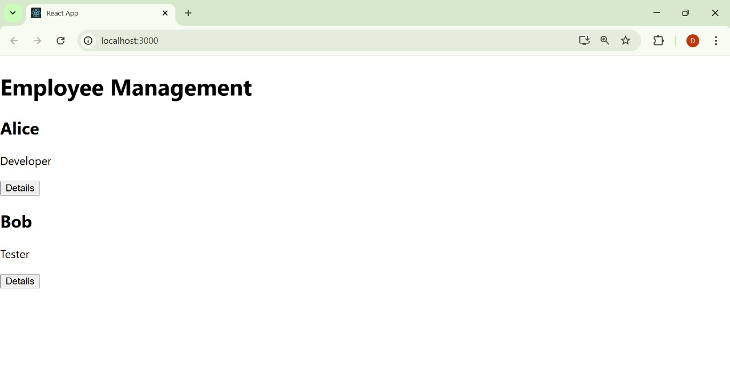
15. ReactJS-HOL
Create a React App named “ticketraisingapp” which will help to raise a complaint and get it resolved. Create a component named “ComplaintRegister” with a form containing a textbox to enter the employee name and a textarea to enter the complaint. Use “handleSubmit” event of the button to submit the complaint and generate a Reference number for further follow ups in the alert box.
Code:

ComplaintRegister.js

import React, { useState } from "react";
function ComplaintRegister() {
const [employeeName, setEmployeeName] = useState("");
const [complaint, setComplaint] = useState("");
const handleSubmit = (e) => {
e.preventDefault();
const transactionId = Math.floor(Math.random() * 100) + 1;
alert(`Thanks ${employeeName}\nYour Complaint was Submitted.\nTransaction ID is: ${transactionId}`
);
setEmployeeName("");
setComplaint("");
};
return (
<div style={{ marginTop: "30px", display: "flex", flexDirection: "column", alignItems: "center" }}>
<h2 style={{ color: "red", fontWeight: "bold" }}>
Register your complaints here!!!
</h2>
<form onSubmit={handleSubmit}>
<table>
<tbody>
<tr>
<td style={{ textAlign: "right", padding: "5px" }}><label>Name:</label></td>
<td style={{ padding: "5px" }}>
<input
type="text"
value={employeeName}
onChange={(e) => setEmployeeName(e.target.value)}
required
/>
</td>
</tr>
<tr>
<td style={{ textAlign: "right", padding: "5px" }}><label>Complaint:</label></td>
<td style={{ padding: "5px" }}>
<textarea
rows="3"
cols="30"
value={complaint}
onChange={(e) => setComplaint(e.target.value)}
required
/>
</td>
</tr>
<tr>
<td colSpan="2" style={{ textAlign: "center", padding: "10px" }}>
<button type="submit">Submit</button>
</td>
</tr>
</tbody>
</table>
</form>
</div>
);
}
export default ComplaintRegister;
App.js

import React from "react";
import ComplaintRegister from "./ComplaintRegister";
function App() {
return (
<div className="App">
<ComplaintRegister />
</div>
);
}
export default App;

Output:

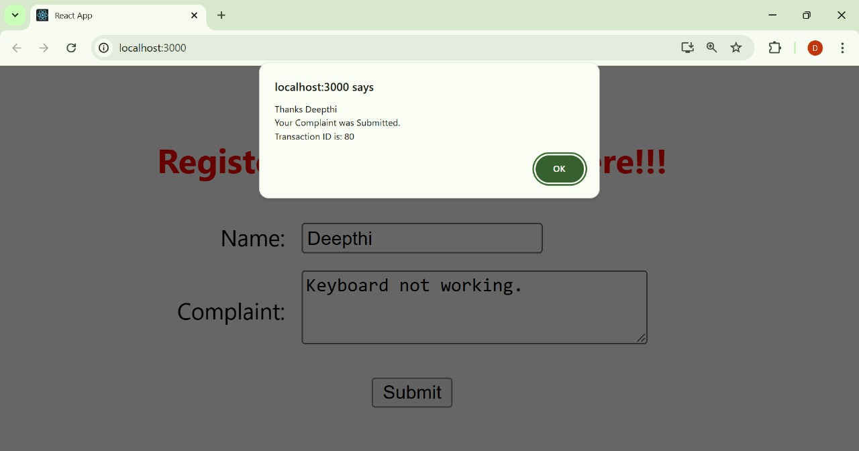

16. ReactJS-HOL
Create a React App named “mailregisterapp” which will have a component named “register.js”. Create a form which accepts the name, email and password and validate the fields as per the following:
- Name should have atleast 5 characters
- Email should have @ and .
- Password should have atleast 8 characters.
Ensure that validations are implemented through eventhandle and eventsubmit of a form.

Code:
Register.js
import React, { useState } from "react";
function Register() {
const [name, setName] = useState("");
const [email, setEmail] = useState("");
const [password, setPassword] = useState("");
const handleSubmit = (e) => {
e.preventDefault();
if (name.trim().length < 5) {
alert("Full Name must be 5 characters long!");
return;
}
if (!email.includes("@") || !email.includes(".")) {
alert("Email is not valid!");
return;
}
if (password.length < 8) {
alert("Password must be at least 8 characters long!");
return;
}
alert("Registration Successful!");
setName("");
setEmail("");
setPassword("");
};
return (
<div style={{ marginTop: "40px", display: "flex", flexDirection: "column", alignItems: "center" }}>
<h2 style={{ color: "red", fontWeight: "bold" }}>Register Here!!!</h2>
<form onSubmit={handleSubmit}>
<table>
<tbody>
<tr>
<td style={{ textAlign: "right", padding: "10px" }}><label>Name:</label></td>
<td style={{ padding: "10px" }}>
<input
type="text"
value={name}
onChange={(e) => setName(e.target.value)}
/>
</td>
</tr>
<tr>
<td style={{ textAlign: "right", padding: "10px" }}><label>Email:</label></td>
<td style={{ padding: "10px" }}>
<input
type="text"
value={email}
onChange={(e) => setEmail(e.target.value)}
/>
</td>
</tr>
<tr>
<td style={{ textAlign: "right", padding: "10px" }}><label>Password:</label></td>
<td style={{ padding: "10px" }}>
<input
type="password"
value={password}
onChange={(e) => setPassword(e.target.value)}
/>
</td>
</tr>
<tr>
<td colSpan="2" style={{ textAlign: "center", paddingTop: "10px" }}>
<button type="submit">Submit</button>
</td>
</tr>
</tbody>
</table>
</form>
</div>
);
}
export default Register;
App.js
import React from "react";
import Register from "./Register";
function App() {
return (
<div className="App">
<Register />
</div>
);
}
export default App;

Output:

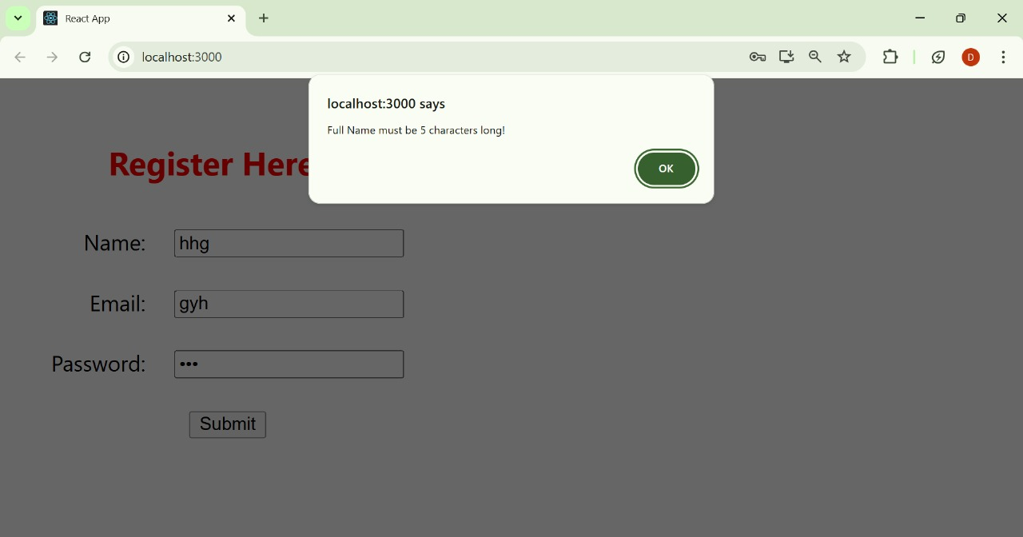

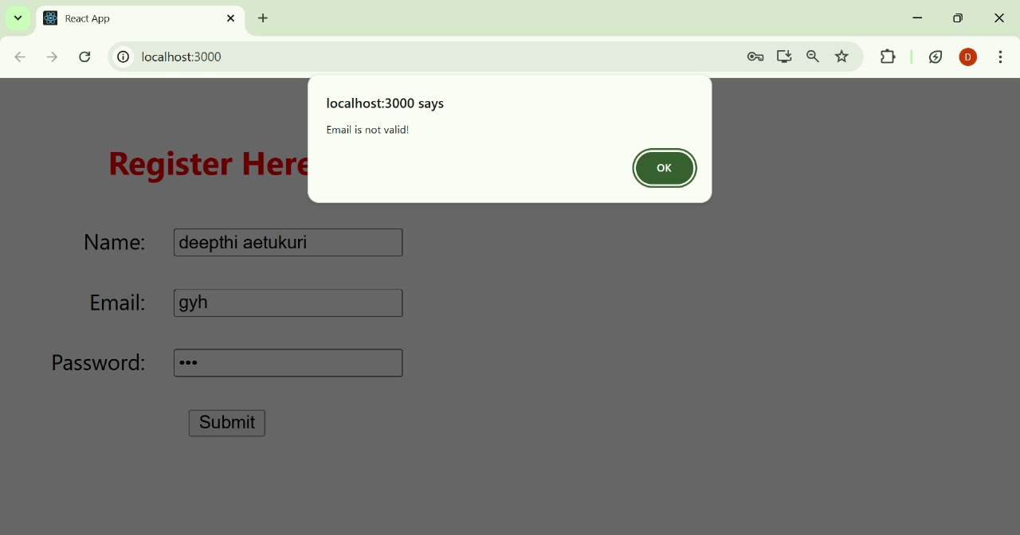
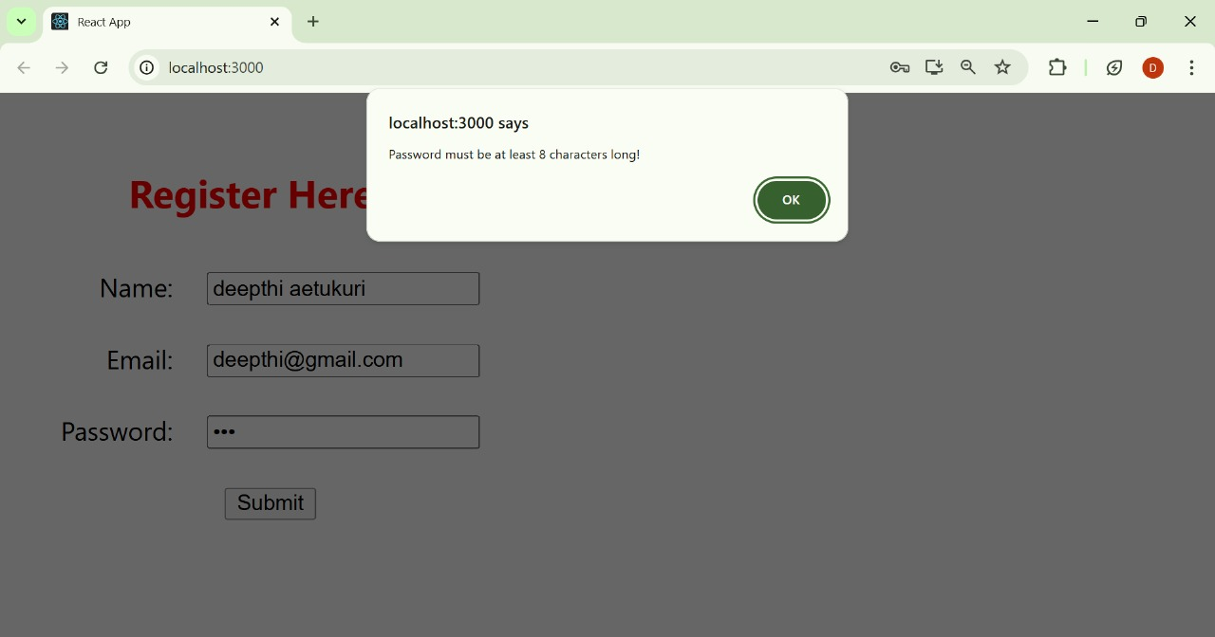

17. ReactJS-HOL
Create a React Application “fetchuserapp” which will retrieve the user details from https://api.randomuser.me/ and display the title, firstname and image of a user.
Code:
App.js
import React from 'react';
import './App.css';
import Getuser from './Getuser';
function App() {
return (
<div className="App">
<h1>Random User</h1>
<Getuser />
</div>
);
}
export default App;
Getuser.js

import React, { Component } from 'react';
class Getuser extends Component {
constructor() {
super();
this.state = {
user: null
};
}
async componentDidMount() {
try {
const response = await fetch('https://api.randomuser.me/');
const data = await response.json();
this.setState({ user: data.results[0] });
} catch (error) {
console.error('Error fetching user:', error);
}
}
render() {
const { user } = this.state;
return (
<div style={{ textAlign: 'center', marginTop: '40px' }}>
{user ? (
<div>
<h2>
{user.name.title} {user.name.first}
</h2>
<img src={user.picture.large} alt="User" />
</div>
) : (
<p>Loading user...</p>
)}
</div>
);
}
}
export default Getuser;

index.js
import React from 'react';
import ReactDOM from 'react-dom/client';
import './index.css';
import App from './App';
const root = ReactDOM.createRoot(document.getElementById('root'));
root.render(
<React.StrictMode>
<App />
</React.StrictMode>
);

Output:

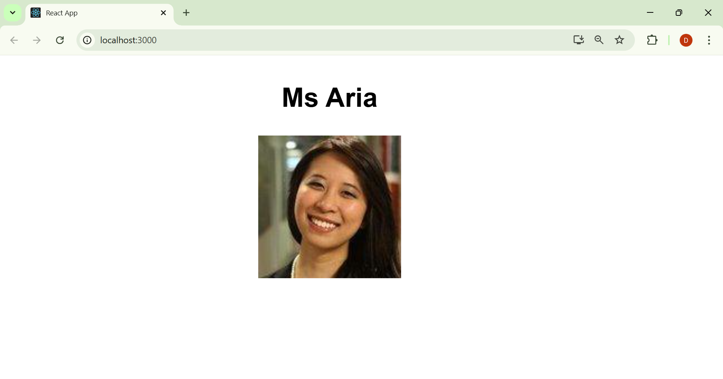

18. ReactJS-HOL
My Academy team at Cognizant want to create a dashboard containing the details of ongoing and completed cohorts. A react application is created which displays the detail of the cohorts using React component. You are assigned the task of unit testing the component to ensure it’s free of bugs.
Code:

setupTests.js

import { configure } from "enzyme";
import Adapter from "enzyme-adapter-react-16";
configure({ adapter: new Adapter() });

CohortDetails.test.js

import React from "react";
import { mount, shallow } from "enzyme";
import CohortDetails from "./CohortDetails";
import { CohortData } from "./Cohort";
describe("Cohort Details Component", () => {
const cohort = CohortData[0]; // assuming at least 1 item
test("should create the component", () => {
const wrapper = shallow(<CohortDetails />);
expect(wrapper.exists()).toBe(true);
});
test("should initialize the props", () => {
const wrapper = mount(<CohortDetails cohort={cohort} />);
expect(wrapper.props().cohort).toEqual(cohort);
});
test("should display cohort code in h3", () => {
const wrapper = mount(<CohortDetails cohort={cohort} />);
expect(wrapper.find("h3").text()).toContain(cohort.cohortCode);
});
test("should always render same html", () => {
const wrapper = shallow(<CohortDetails cohort={cohort} />);
expect(wrapper).toMatchSnapshot();
});
});

Output:

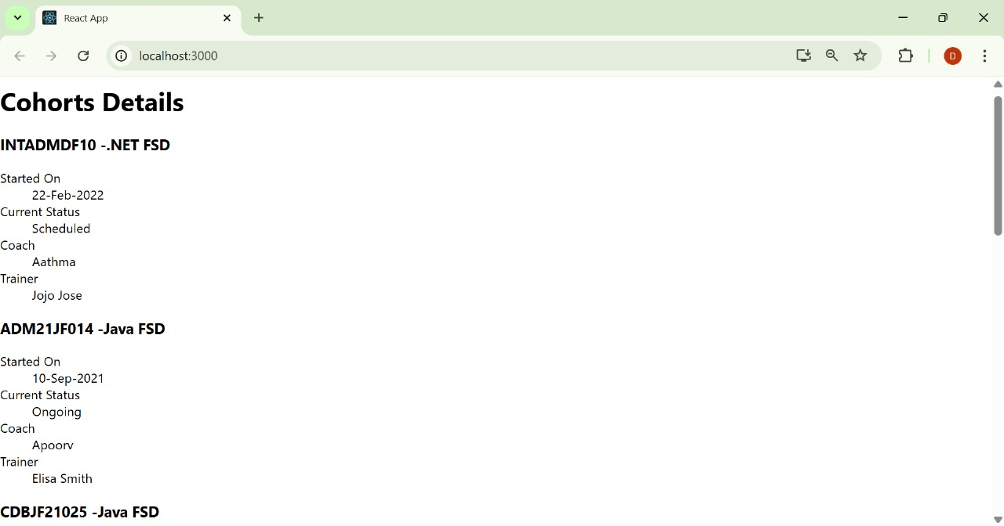

19. ReactJS-HOL
As an intern at OpenAI you are assigned the task of creating and testing a React application which will fetch and display a list of repository names for a given user.
Code:
App.js
import React from "react";
function App() {
const repos = [
"appscentricsolutions",
"ArrayListDemo",
"ArrayListDemo01",
"AzureDevopsDemoProductsApi",
"CleanArchitecture",
"ContosoUniversity",
"CTS-Stage3-0122",
"DelegatesDemo",
"Demo01",
"EventsDemo",
"FISGlobal-0721",
"GenericCollections",
"GenericsDemo",
"GitHubDemoApp",
"GitTestFolder"
];
return (
<div style={styles.container}>
<h1 style={styles.heading}>Git repositories of User - TechieSyed</h1>
<ul style={styles.list}>
{repos.map((repo, index) => (
<li key={index} style={styles.item}>{repo}</li>
))}
</ul>
</div>
);
}
const styles = {
container: {
fontFamily: "Segoe UI, Tahoma, Geneva, Verdana, sans-serif",
textAlign: "center",
marginTop: "40px",
padding: "20px",
},
heading: {
fontSize: "28px",
fontWeight: "bold",
marginBottom: "30px",
},
list: {
listStyleType: "none",
padding: 0,
margin: 0,
},
item: {
fontSize: "18px",
lineHeight: "1.8",
},
};
export default App;
GitClient.js
import axios from "axios";
class GitClient {
async getRepositories(username) {
const response = await axios.get(`https://api.github.com/users/${username}/repos`);
return response.data.map(repo => repo.name);
}
}
export default GitClient;
Output:

